Chintan R. Timbadiya
214-940-4720, ctimbadiya101@gmail.com
Dallas, TX
January 28, 2026
Dear Hiring Manager
Sundt Construction
Patagonnia, AZ
Subject: Application for Quality Control Inspector 1 Position
Dear Hiring Manager,
I am writing to express my strong interest in the Quality Control Inspector position with Sundt. With over eight years of progressive experience in construction engineering, project coordination, and field operations, along with my OSHA-30, CMIT certification and Master’s degree in Civil Engineering from the University of Texas at Arlington, I am excited about the opportunity to contribute to Sundt’s employee-owned culture and commitment to excellence.
Throughout my career, I have supported project teams by managing RFIs, submittals, change orders, as-built drawings, and technical documentation while maintaining strong relationships with owners, designers, subcontractors, and suppliers. In my previous roles as Field Engineer, Project Engineer and Senior Project Engineer, I worked closely with superintendents and project managers to resolve field issues, maintain quality standards, and ensure projects were delivered safely, on time, and within budget. I have also prepared meeting minutes, supported cost forecasting, tracked quantities, and assisted with project controls and documentation.
In addition, I bring hands-on experience with BIM coordination, Bluebeam, Primavera P6, AutoCAD, and digital project management platforms. I have worked LEED-related documentation during my BIM project, quality control programs, and safety initiatives across multiple large-scale projects, including commercial, residential, and industrial developments. My background allows me to understand both the technical and operational aspects of construction, ensuring effective coordination between field and office teams.
Currently working in transportation and infrastructure engineering, I regularly conduct site observations, field investigations, and data analysis for public and private clients. This experience has further strengthened my attention to detail, communication skills, and ability to work in safety-sensitive environments. I am actively pursuing LEED GA and PMP certifications and preparing for the FE exam to strengthen my technical and project management expertise.
What excites me most about Sundt is its employee-ownership model and strong focus on long-term growth, accountability, and craftsmanship. I value teamwork, integrity, and continuous improvement, and I am eager to contribute to projects that positively impact communities while growing as an employee-owner.
Thank you for considering my application. I would welcome the opportunity to further discuss how my technical expertise, field experience, and dedication can contribute to Sundt’s continued success.
Sincerely,
Chintan R. Timbadiya

Project 1 Highlights :- 12-Story Residential & Commercial Development
1) Foundation Phase: On-site during foundation construction activities, supporting layout, inspection, and quality control for a 12-story residential and commercial building.
2) 11th Floor Slab Pour: Supervising and coordinating concrete placement for the 11th-floor slab to ensure compliance with structural and quality standards.
3) Masonry Work: Overseeing masonry installation and coordinating with trade partners to maintain schedule, safety, and workmanship standards.
4) Final Phase: Supporting final construction, inspections, and closeout activities during the finishing stage of the 12-story residential and commercial project.
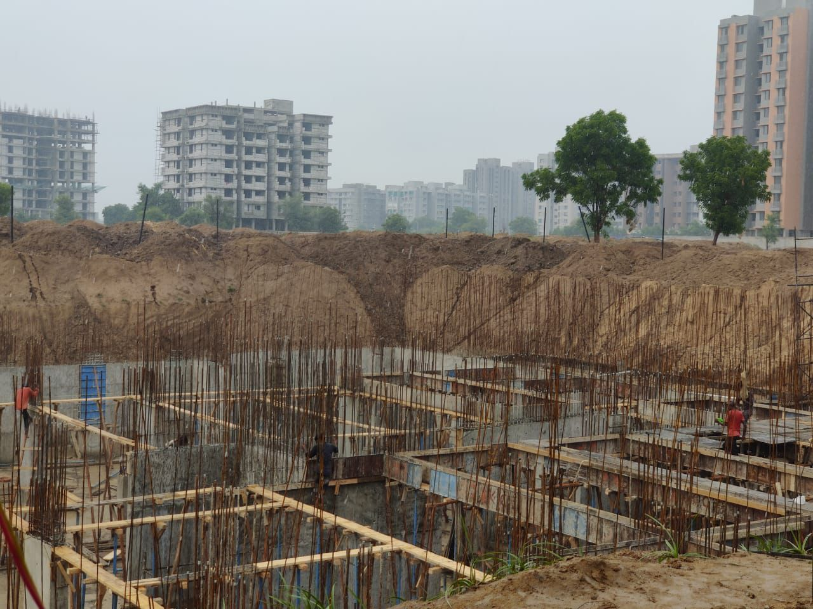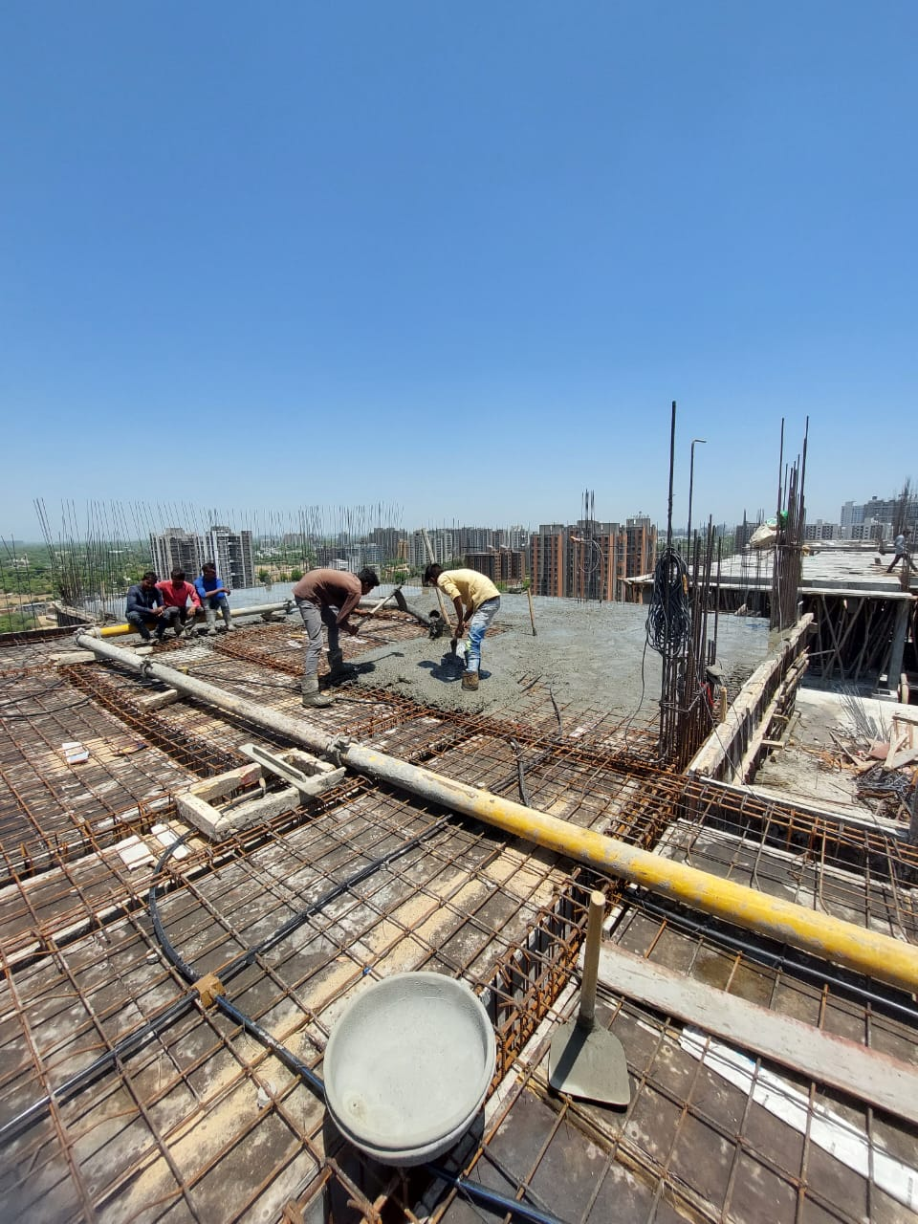
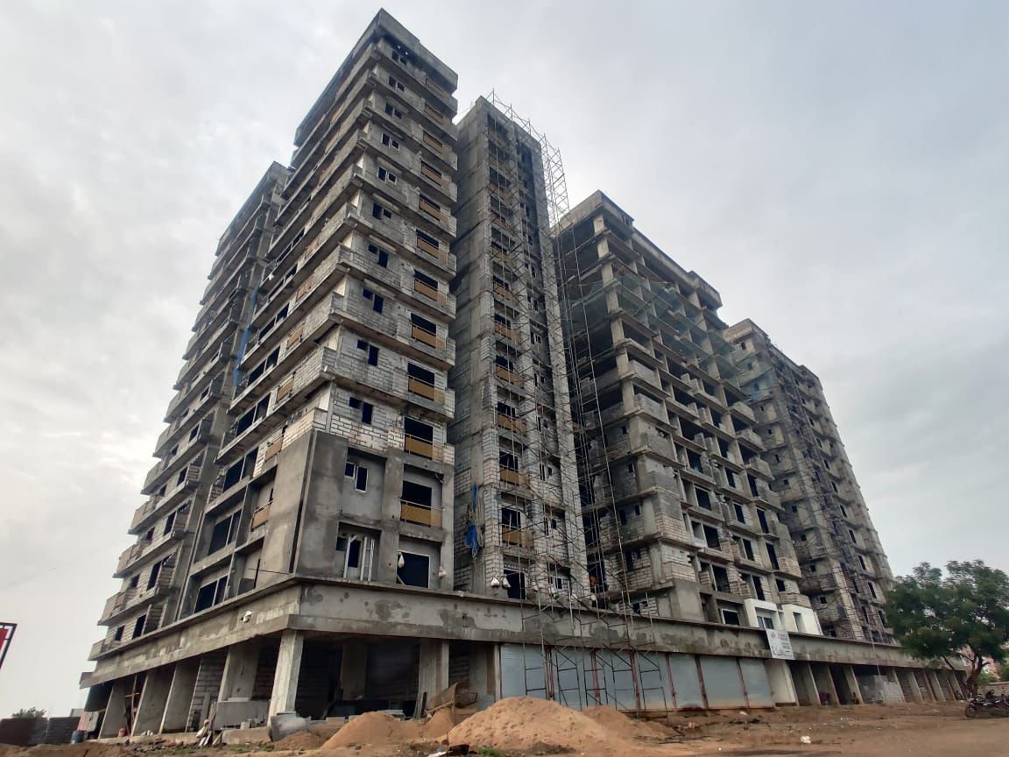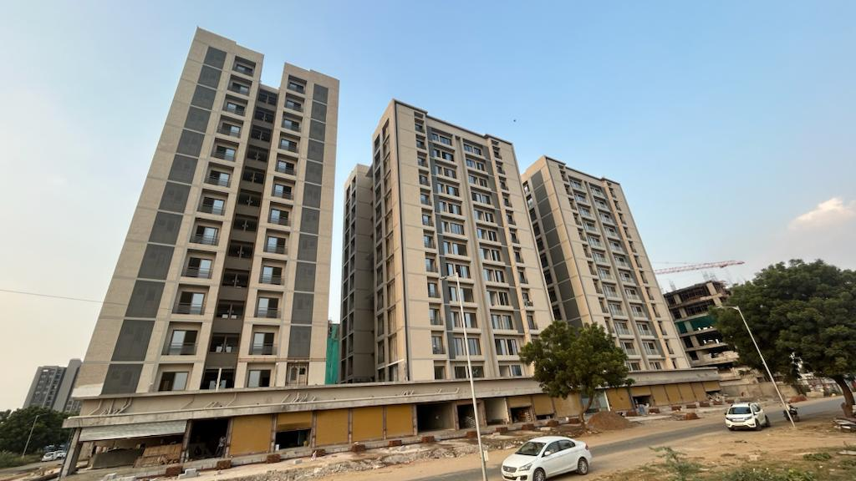

Project 2 Highlights :- Industrial Shed Development
1) Masonry & Beam Preparation: Brickwork completed up to sill level for mid-level beam casting in a load-bearing structure supported on pile foundations.
2) Plastering Initiation: Plaster work commenced on one side of the building as part of the finishing phase for the pile-supported load-bearing structure.
3) Phase 1 Progress: Front elevation plaster work completed for Phase 1, meeting quality and schedule benchmarks on the pile-based structural system.
4) Architectural Visualization: 3D perspective view of the industrial shed project provided by the architectural design team for design coordination and construction planning.
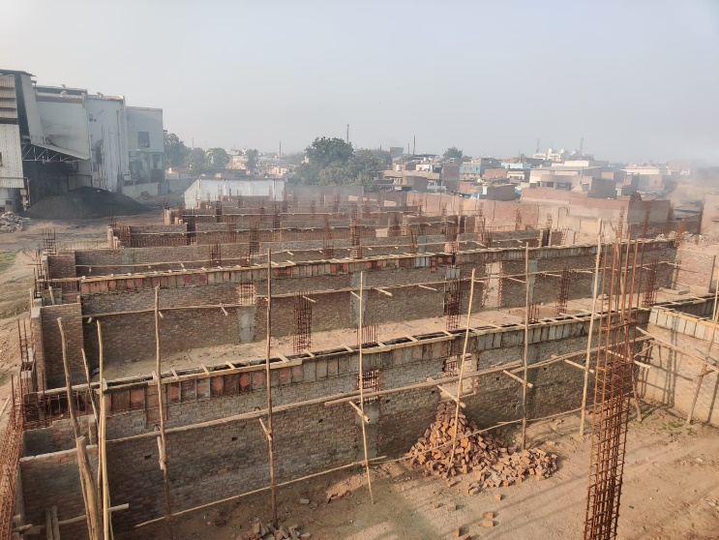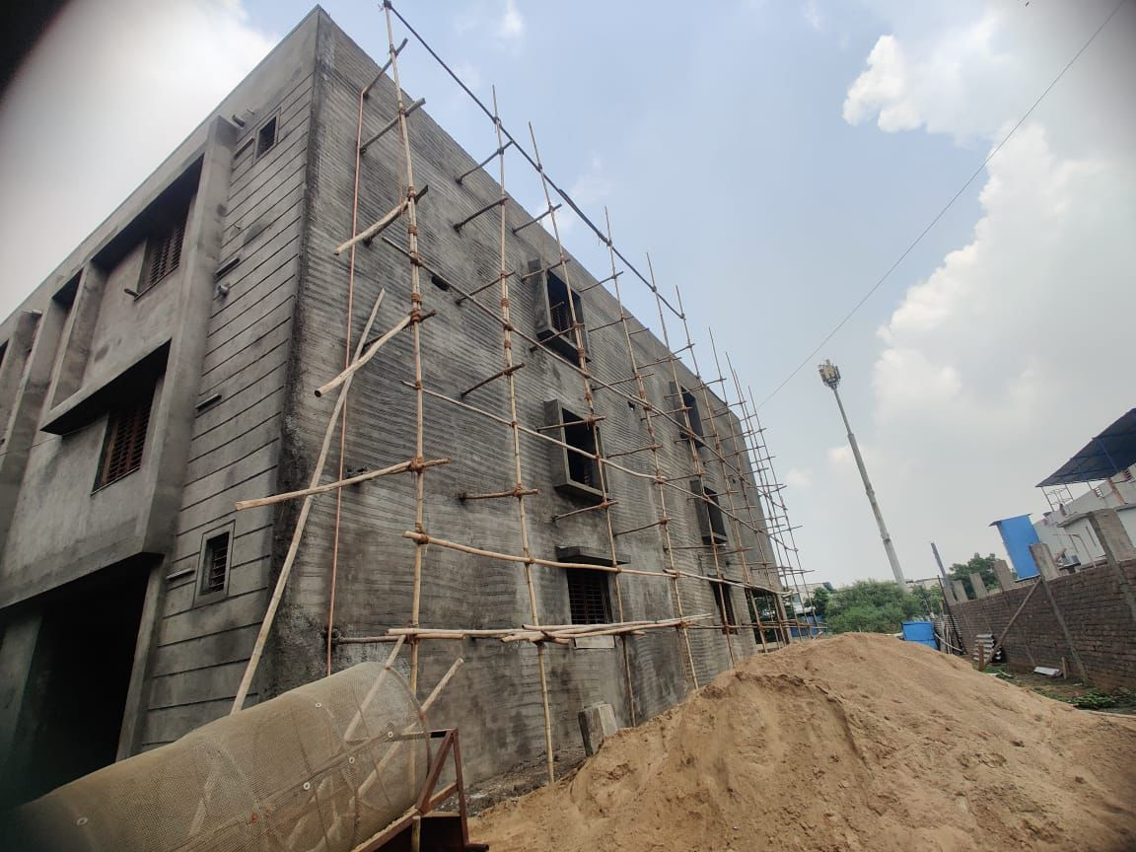
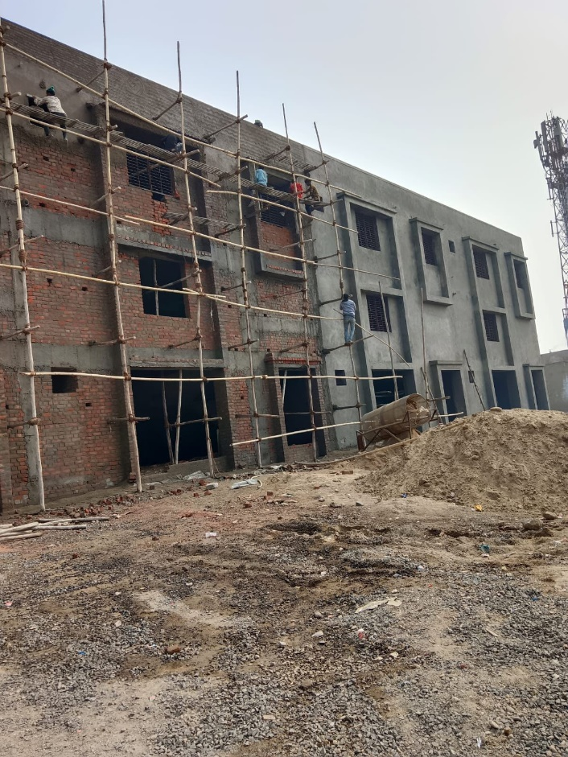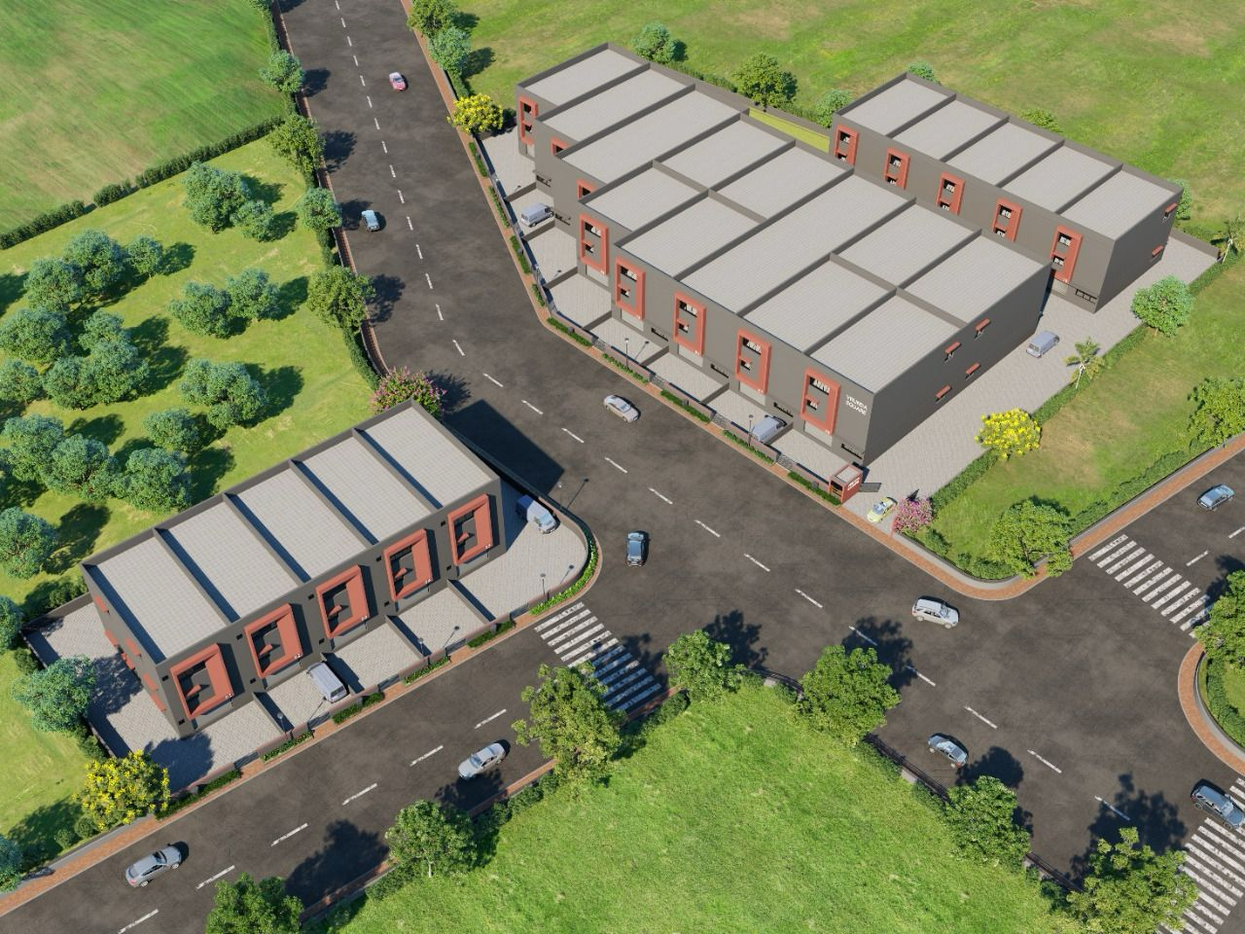

Project 3 Highlights :- Resort Project on Hill
1) Pre-Casting Structural Inspection: Reinforcement steel work prepared for casting and reviewed by the owner’s Project Engineer and architect, receiving approval to proceed.
2) Overhead Water Tank Dome Casting: Final dome casting in progress for the overhead water tank.
3) High-Level Slab Casting: Parallel casting of the 21-foot-high slab with integrated Canopy, coordinated alongside overhead tank construction.
4) Cantilever Canopy Construction: Concrete pouring in progress for the 4-foot cantilevered Canopy.
5) Post-Structural Completion - Front View: Front elevation of the building after completion of major concrete works at ground level.
6) Overall Elevation - Construction Phase: Distant elevation view of the structure during active construction, highlighting overall progress and form.

